Contents
Figure S1: Full synteny alignment 2
Figure S2-4: Extent of recombination cessation in larks 3
Figure S5: Stratum formation on chromosome 4 6
Figure S6-8: Sexual dimorphism 7
Figure S9-11: Life history 9

Figure S1: Full synteny alignment
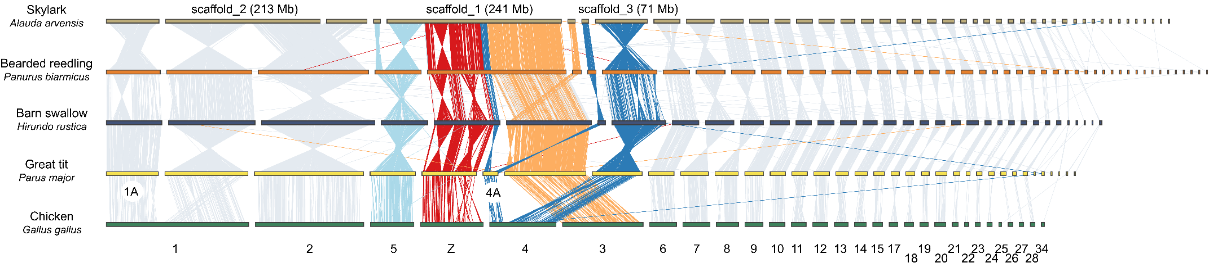
Figure S1. Pairwise whole-genome synteny alignments across five bird genomess. Each horizontal bar represents one scaffold, with chicken chromosome nomenclature at the bottom. Note that chromosomes 1A and 4A in passerines have resulted through fissions following chicken divergence. All chromosomes involved in neo-sex chromosome stratum formation in Sylvioidea have been highlighted in colours. Note that the Skylark assembly includes a large sex chromosome, involving chromosomes 4A, 3 and 5, as well as a large fusion of chromosomes 1 and 2.

Figure S2-4: Extent of recombination cessation in larks
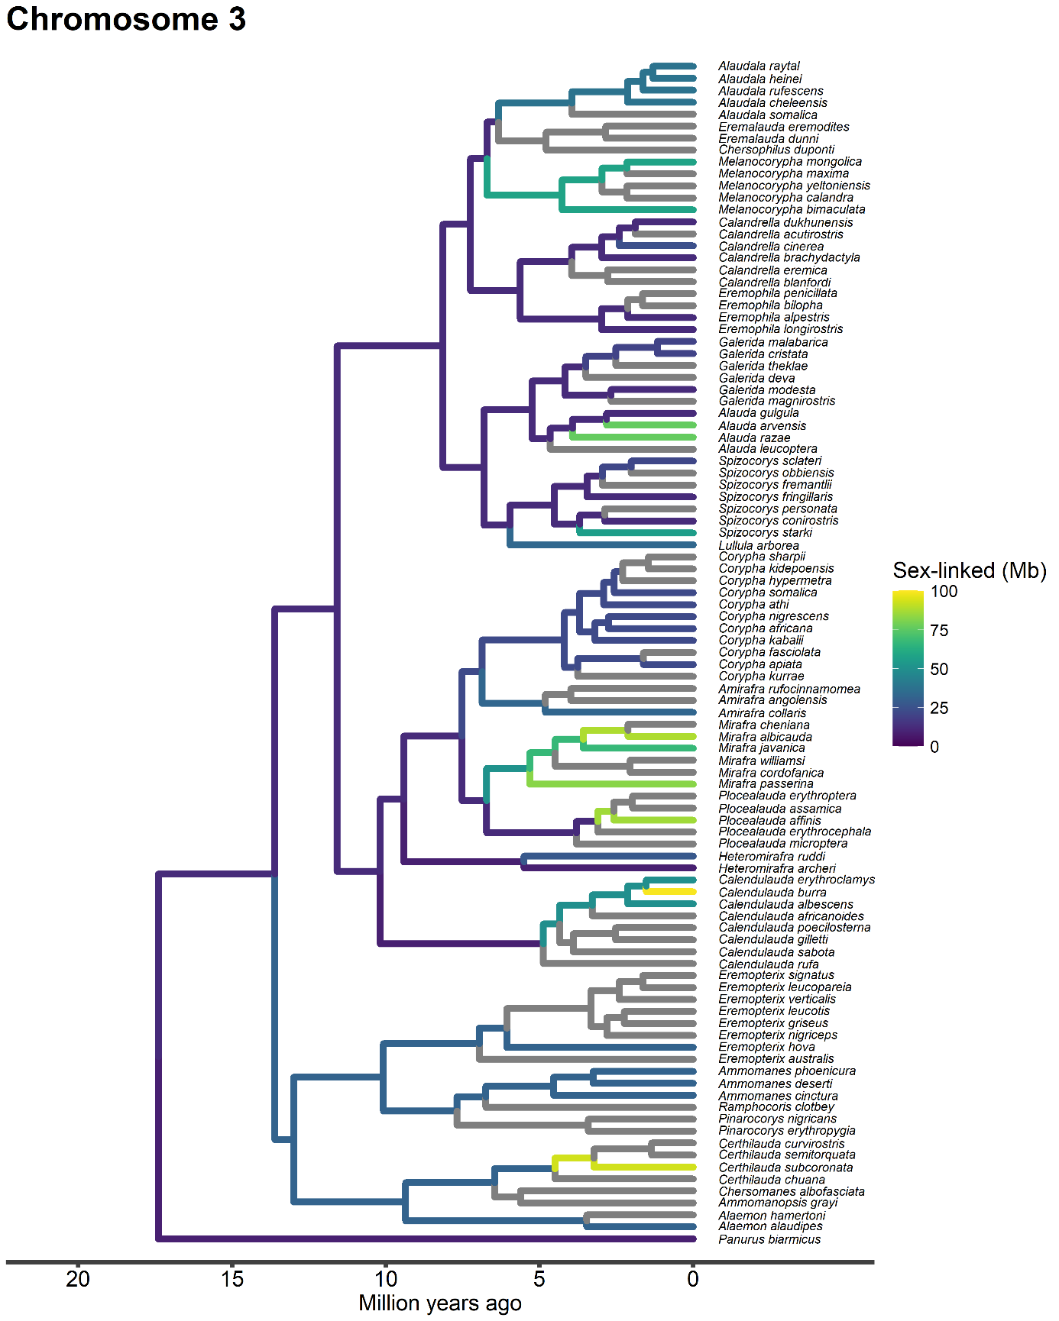
Figure S2. The extent of recombination cessation of chromosome 3 across the lark family. Terminal branches correspond to observations, while internal branches are manually inferred with a parsimony approach. Grey branches correspond to non-sampled lineages. Tree divergence times based on Alström et al., (2023).
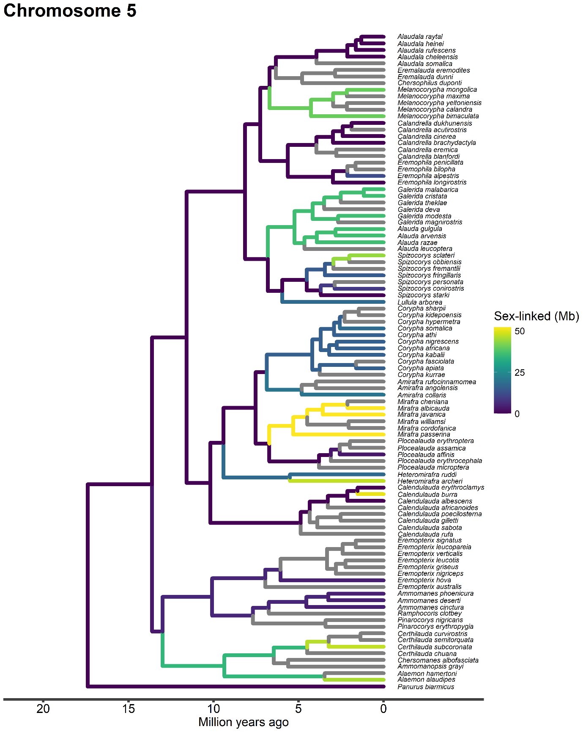
Figure S3. The extent of recombination cessation of chromosome 5 across the lark family. Terminal branches correspond to observations, while internal branches are manually inferred with a parsimony approach. Grey branches correspond to non-sampled lineages. Tree divergence times based on Alström et al., (2023).
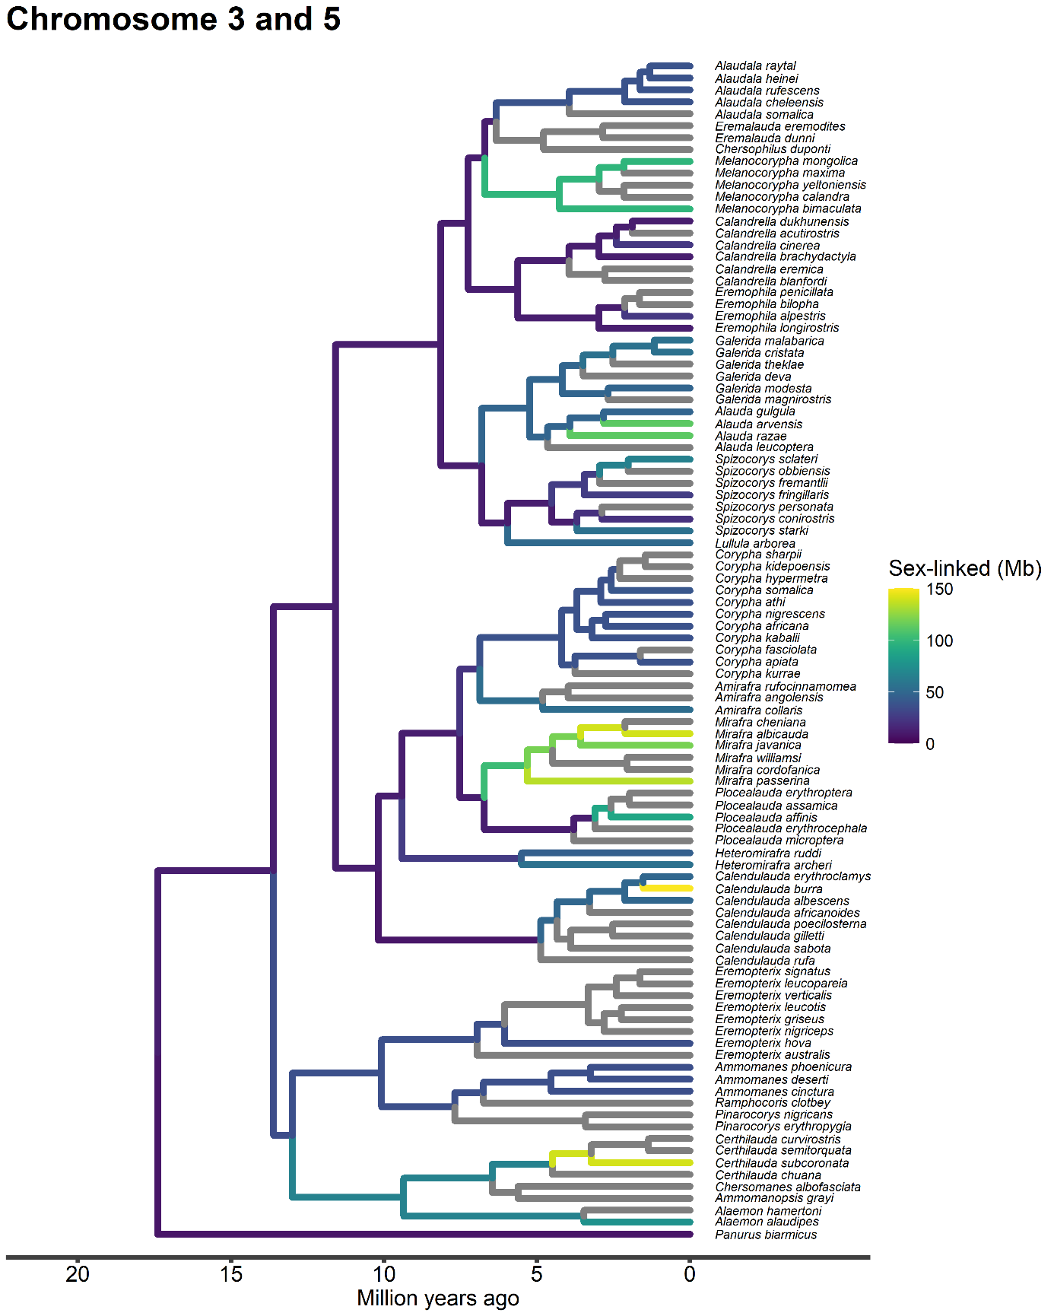
Figure S4. The total extent of recombination cessation of chromosome 3 and 5 across the lark family. Terminal branches correspond to observations, while internal branches are manually inferred with a parsimony approach. Grey branches correspond to non-sampled lineages. Tree divergence times based on Alström et al., (2023).

Figure S5: Stratum formation on chromosome 4
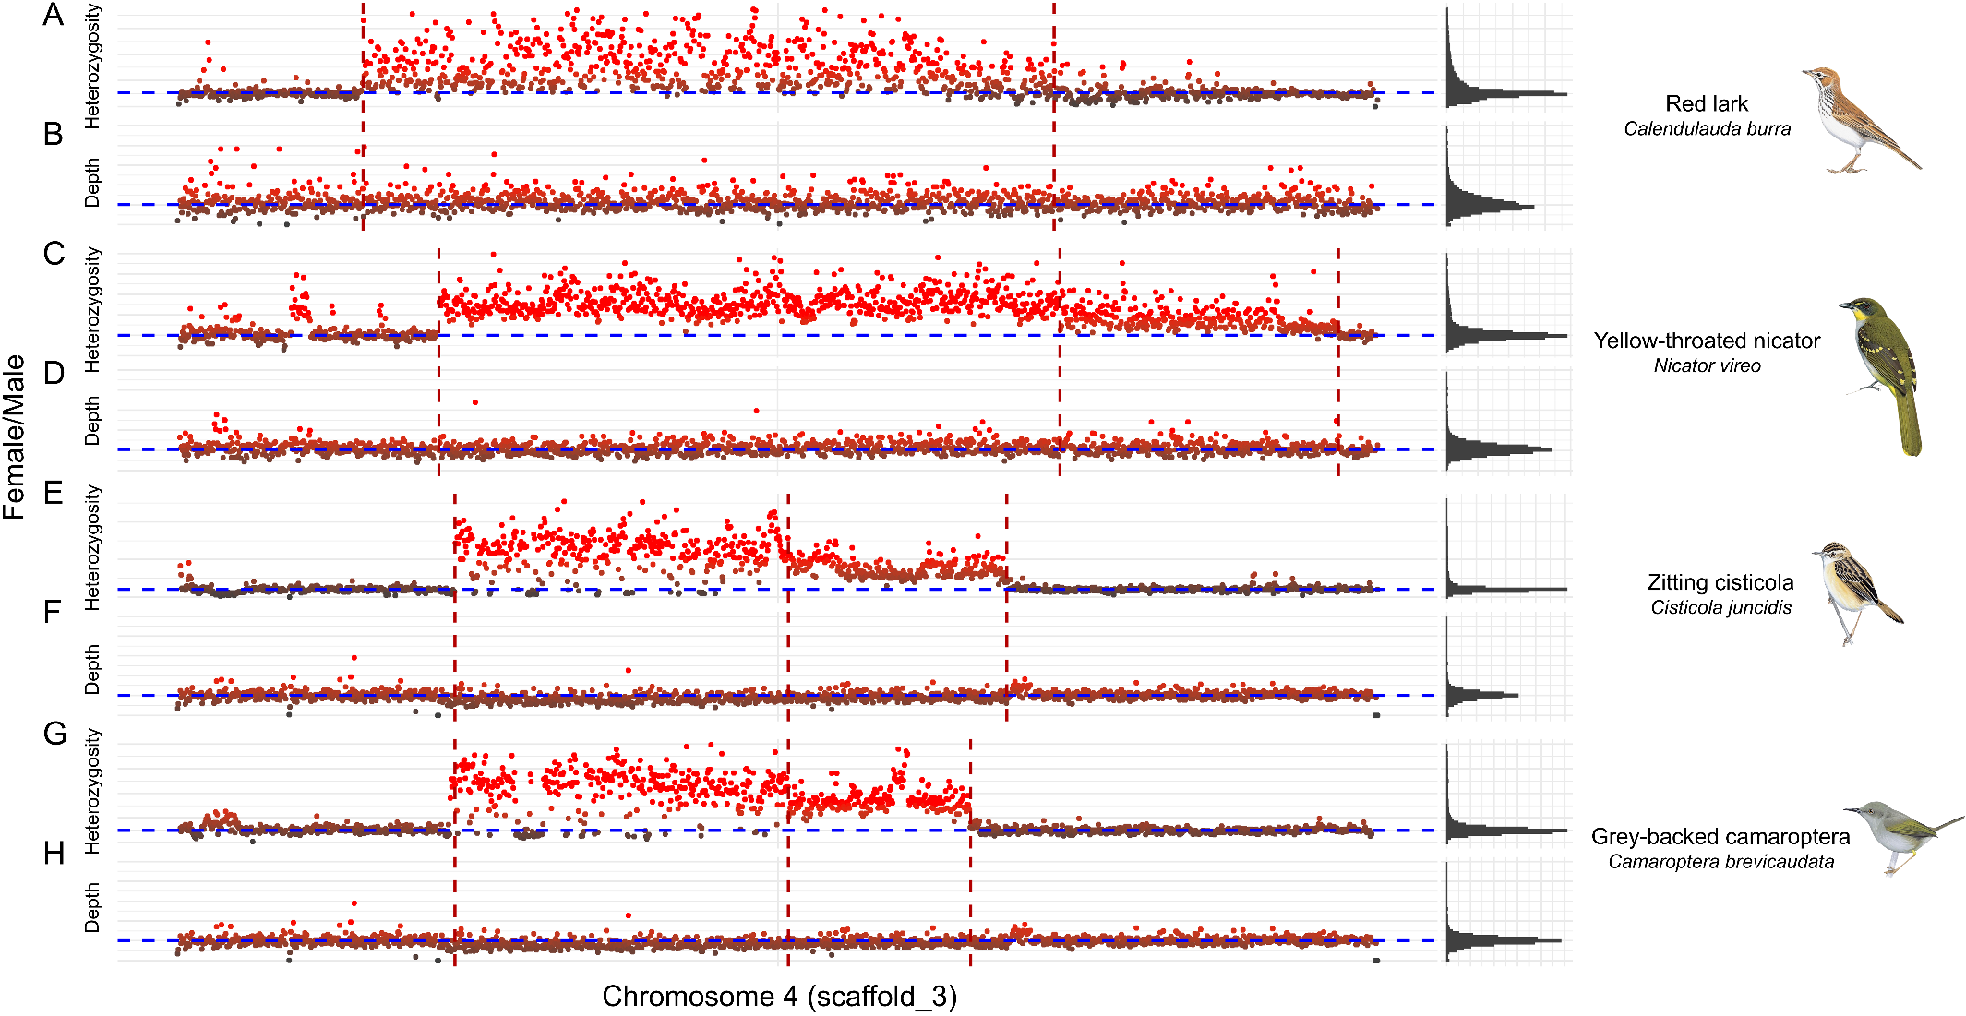
Figure S5. Normalized sex differences (Female/Male) in 50 kb windows on chicken chromosome measured in (A, C, E, G) heterozygosity and, (B, D, F, H) sequencing depth for (A, B) Red lark (Calendulauda burra), (C, D) Yellow-throated nicator (Nicator vireo), (E, F), Zitting cisticola (Cisticola juncidis), and (G, H) Grey-backed camaroptera (Camaroptera brevicaudata). Windows coloured by gradient across individual distributions, with red corresponding to female inflated values. Dashed red lines mark putative stratum boundaries. Dashed blue lines mark genome wide median of normalized sex differences. Histograms show distribution of normalized sex differences across the genome. Illustrations from Birds of the World: Tim Worfolk (Red lark, Zitting cisticola, Grey-backed camaroptera), and John Cox (Yellow-throated nicator).

Figure S6-8: Sexual dimorphism
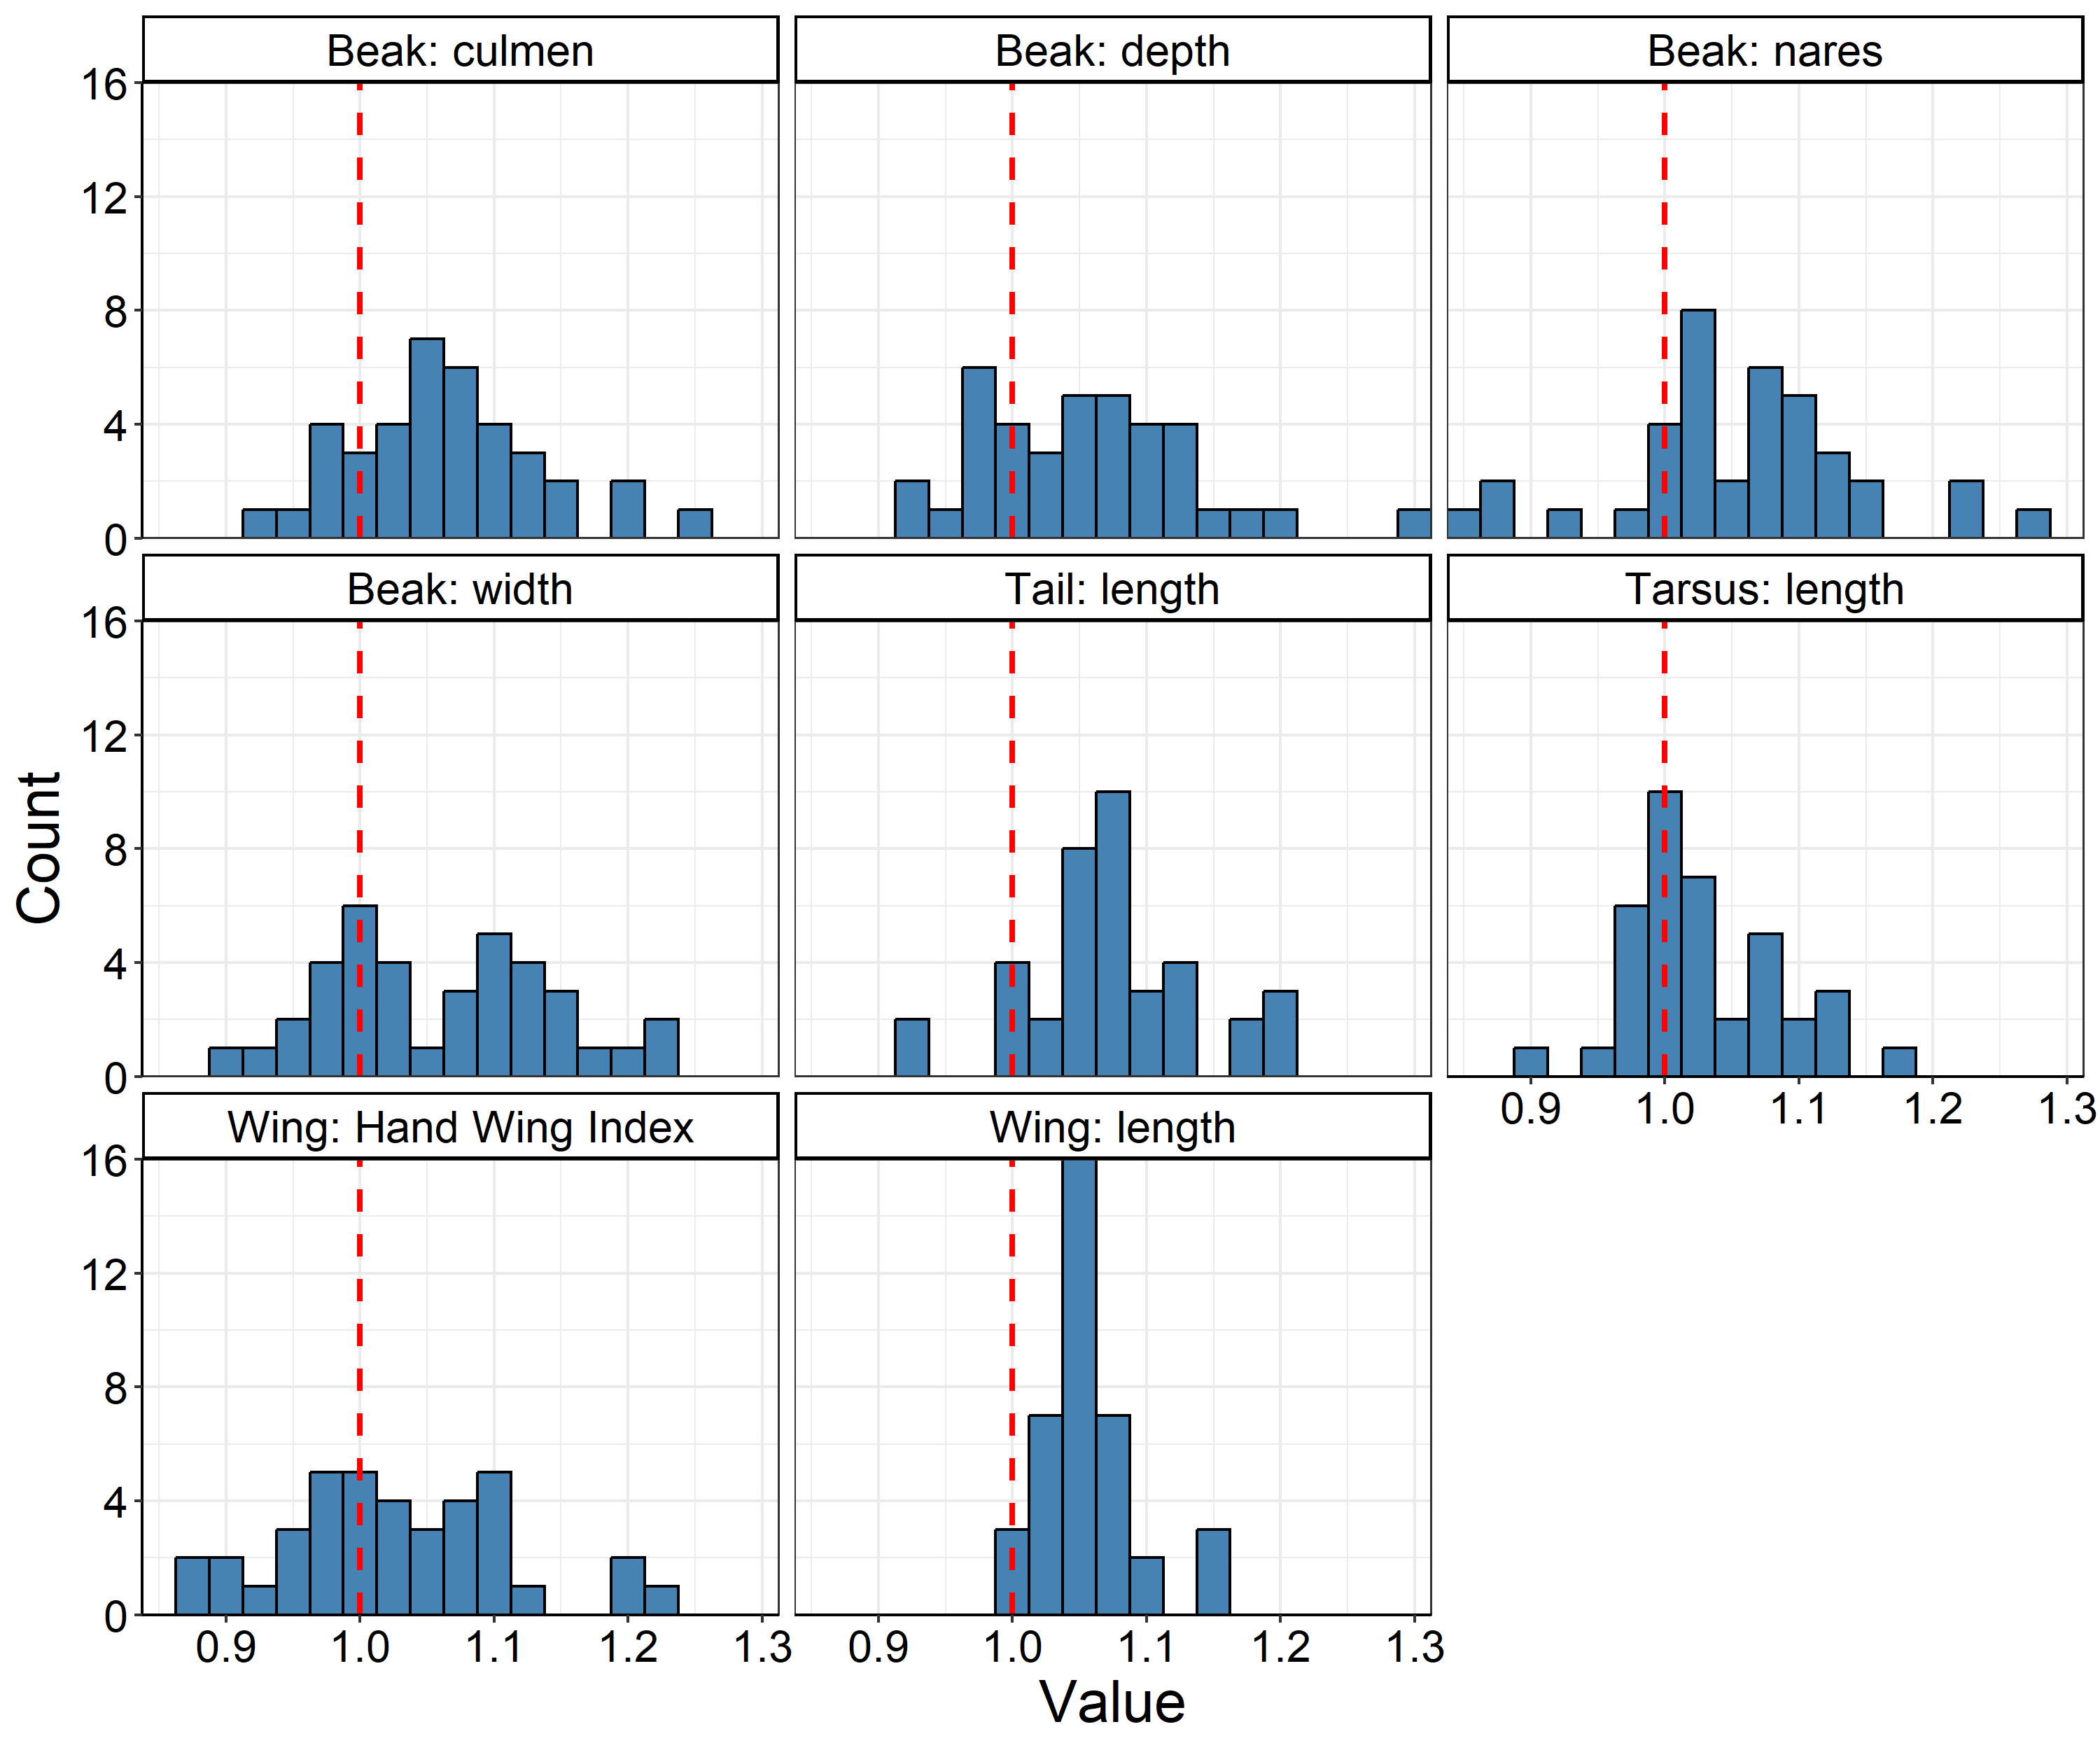
Figure S6. Distribution of male-to-female ratios of traits and species used for analysis of sexual dimorphism. Dashed red line divides species with female-biased size dimorphism (left) and male-biased size dimorphism (right).

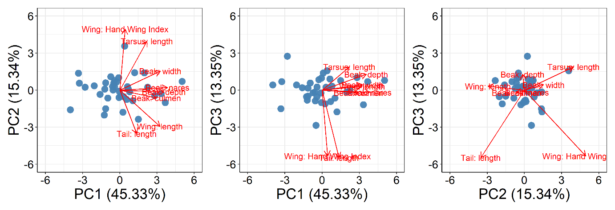
Figure S7. PCA of sexual dimorphism traits using a PCA. (A) PC1 and PC2, (B), PC1 and PC3, (C) PC2 and PC3. Points represent individual species in multivariate trait space. Arrows represent variable loadings scaled by x8 for visualisation. Loadings include male-to-female ratios of: Beak: culmen, Beak: nares, Beak: width, Beak: depth, Tarsus: length, Wing: length, Wing: Hand Wing Index, Tail: length.
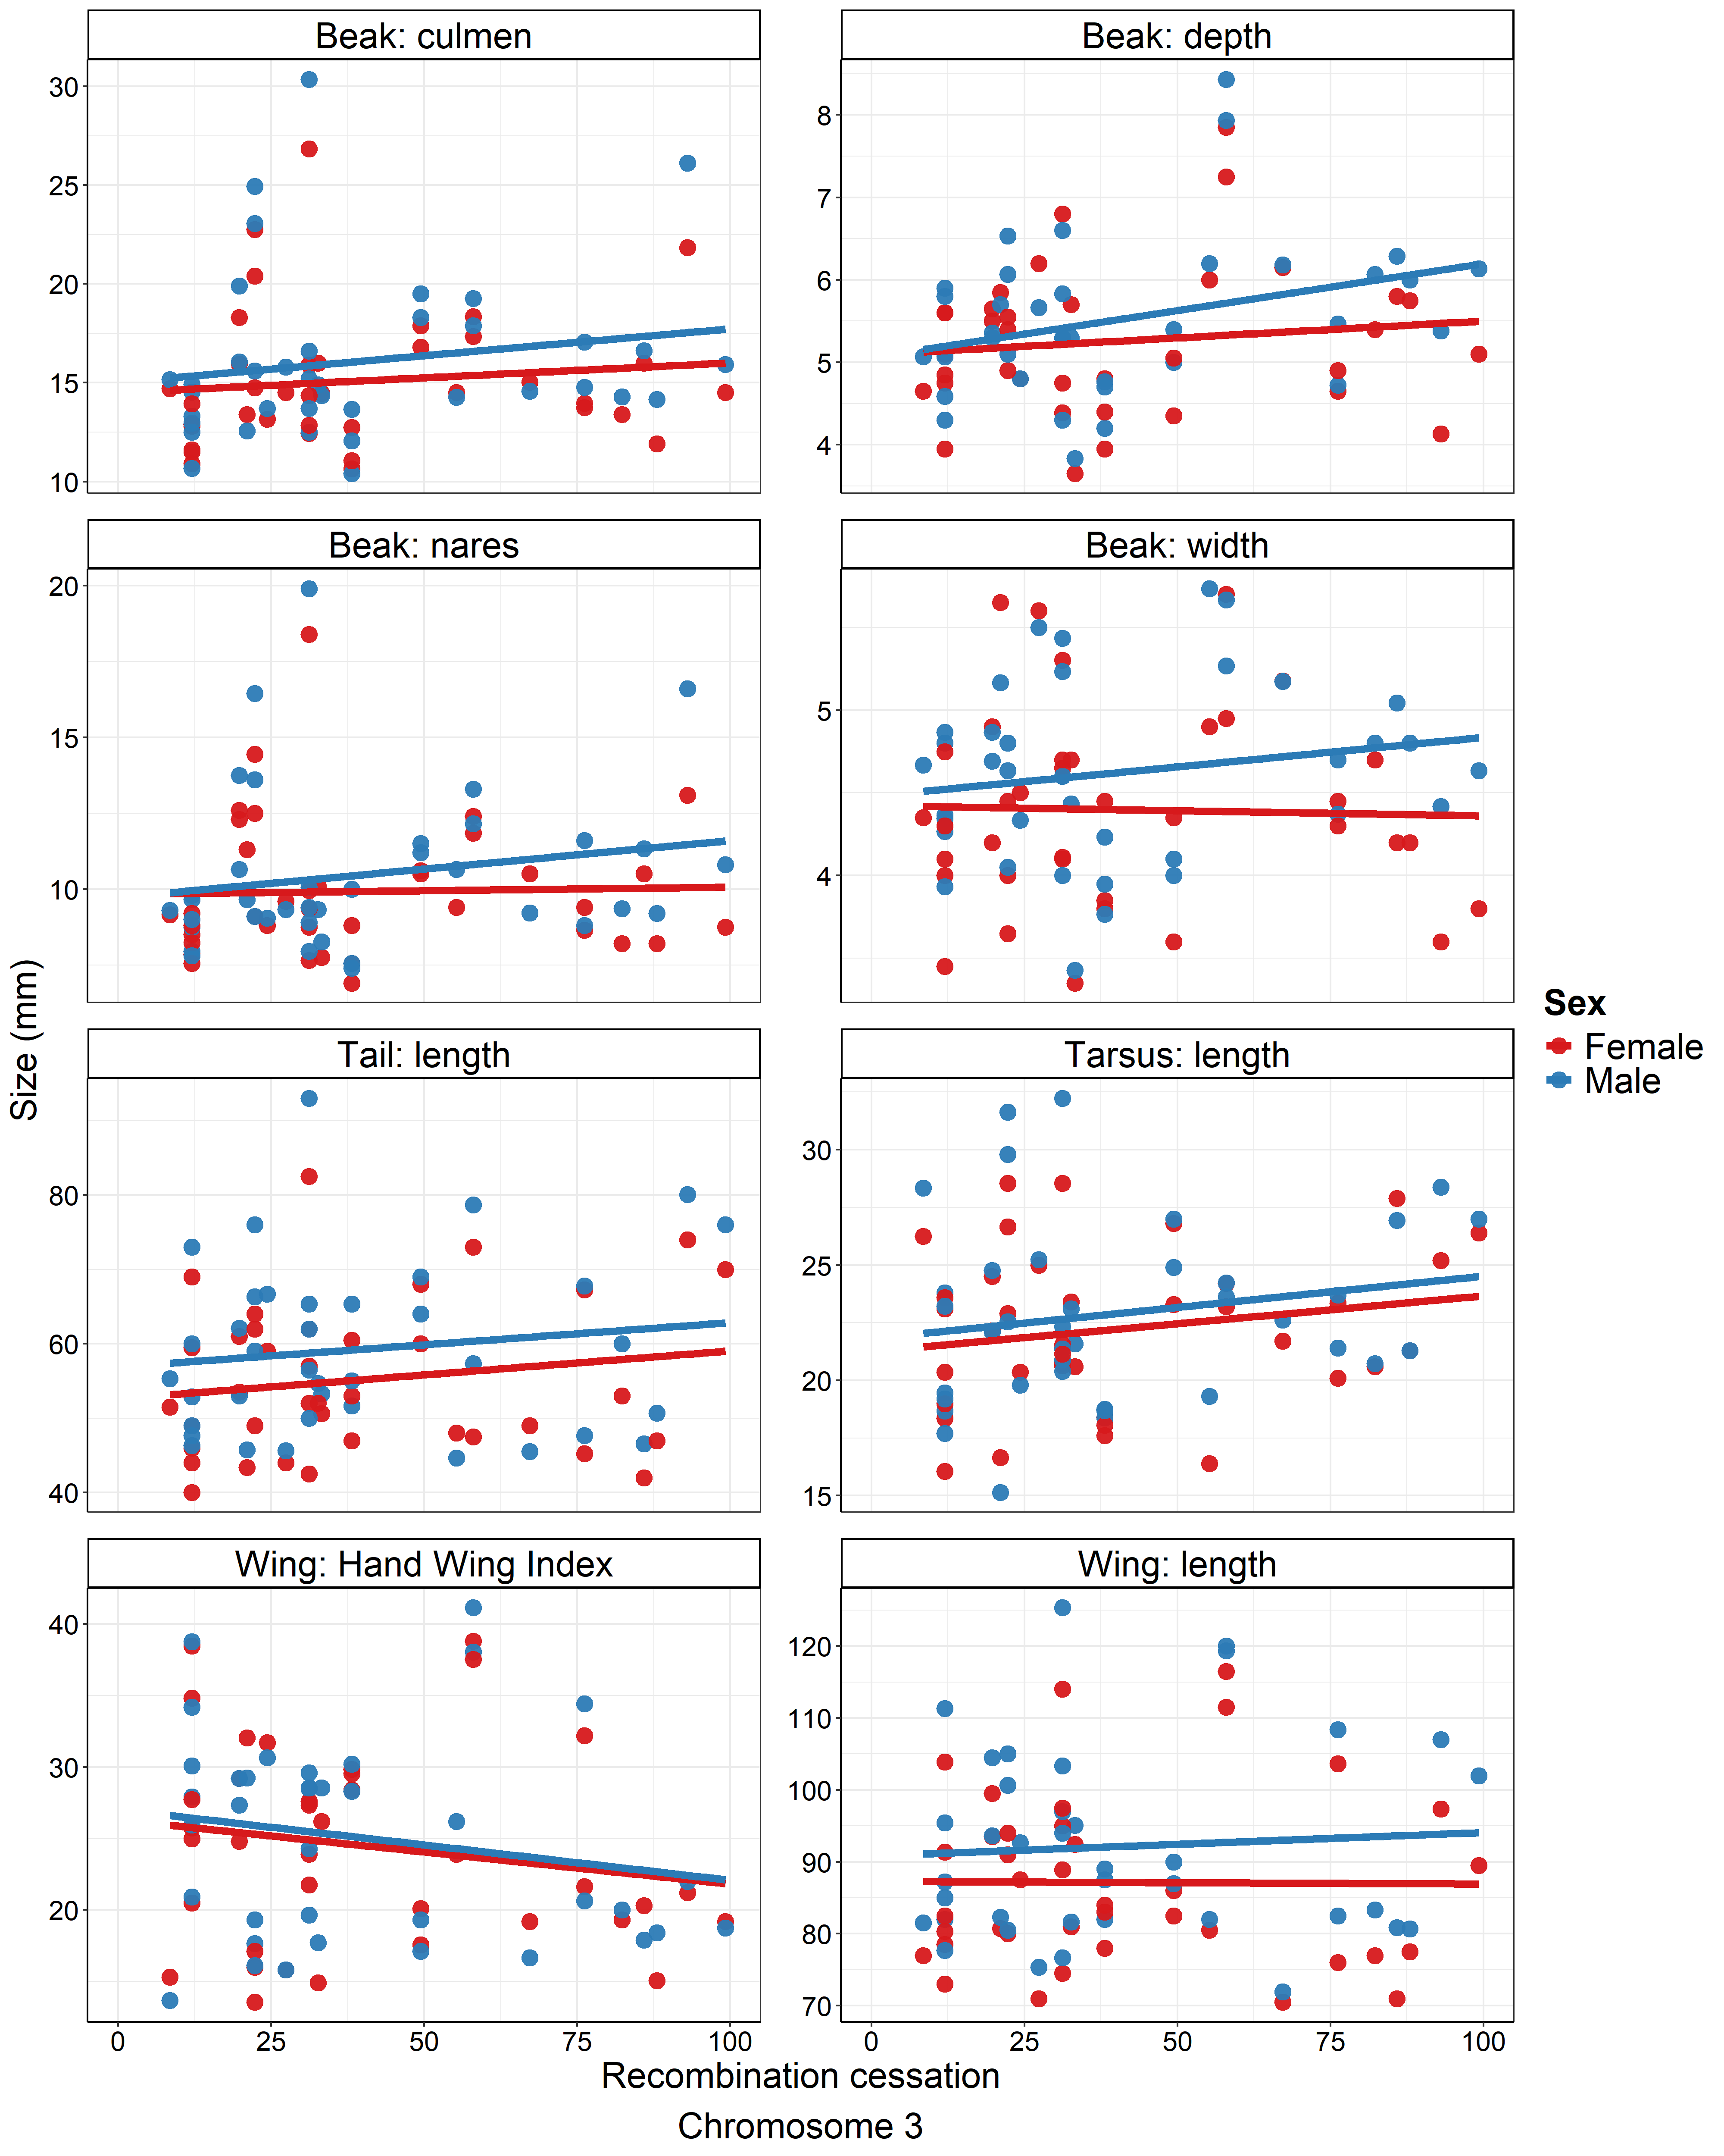
Figure S8. Slopes of female and male size traits as a function of the extent of recombination cessation on chromosome 3.

Figure S9-11: Life history
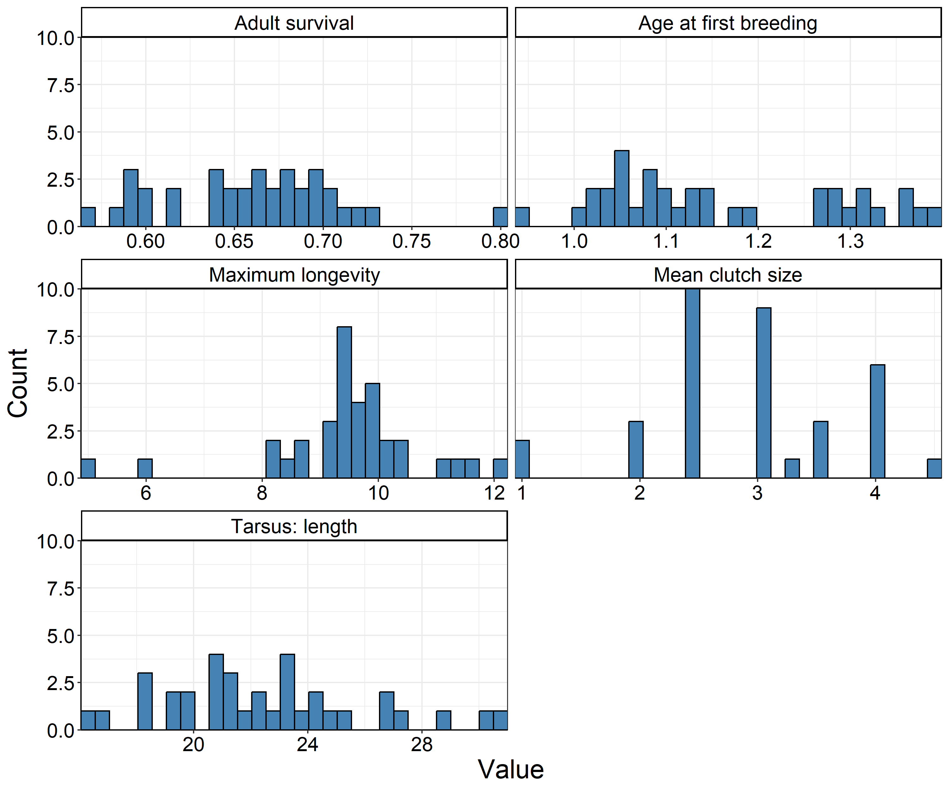
Figure S9. Distribution of life history traits and species used for analysis of life history.

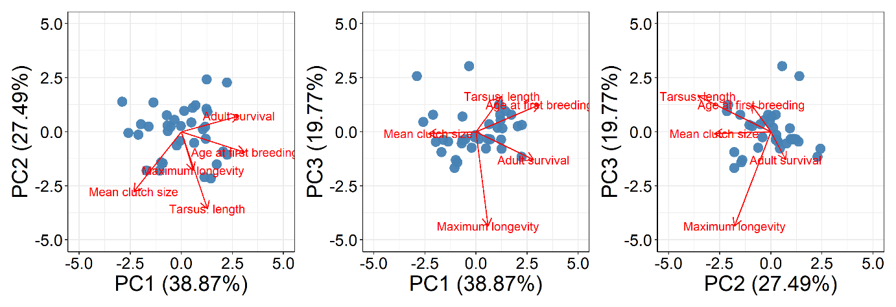
Figure S10. PCA of life history traits using a PCA. (A) PC1 and PC2, (B), PC1 and PC3, (C) PC2 and PC3. Points represent individual species in multivariate trait space. Arrows represent variable loadings scaled by x5 for visualisation. Loadings include: Adult survival, Age at first breeding, Maximum longevity, Mean clutch size, and Tarsus: length.
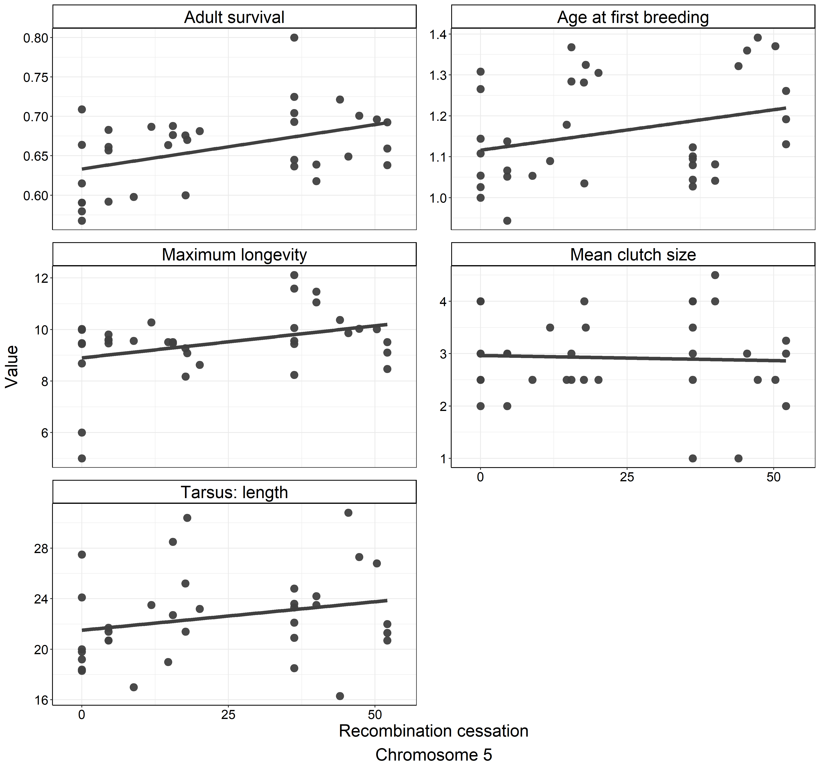
Figure S11. Slopes of life history traits as a function of the extent of recombination cessation on chromosome 5.

